**Multiple Integration**

Integration of multi-variable is called multiple Integration. Repeated definite and indefinite of form $\int_{a}^{b}{\int_{y_{1}}^{y_{2}}{f\left(x,y\right)dydx and \int{\int{f\left(x,y\right)dydx}}}}$ for two variables are called iterated integral. Repeated definite and indefinite of form $\int_{a}^{b}{\int_{y_{1}}^{y_{2}}{\int_{z_{1}}^{z_{2}}{f(x,y,z)}dzdydx and \int{\int{\int{f\left(x,y,z\right)dzd}ydx}}}}$ for three variables

**Evaluation of double integral**

$\int_{a}^{b}{\int_{y_{1}}^{y_{2}}{f\left(x,y\right)dydx }}$, $f\left(x,y\right)$ is first integrated with respect to *y*  treating *x* as constant between the limits $y_{1 }$ and $y_{2 }$ and then the result is integrated with respect to *x*  between the limits *a* and *b .*

**Example1 $\int_{0}^{3}{\int_{x}^{\sqrt{25-x^{2}}}{x dydx }}$**

Sol. $\int_{0}^{3}{\int_{x}^{\sqrt{25-x^{2}}}{x dydx }}=\int_{0}^{3}{x{\left[y\right]}_{x}^{\sqrt{25-x^{2}}}dx=\int_{0}^{3}{x\left[\sqrt{25-x^{2}}-x\right]dx}}$

$=-\frac{1}{2}\int_{0}^{3}{\sqrt{25-x^{2}} d(25-x^{2})}$ $-\int_{0}^{3}{x^{2}dx}$

$$={-\frac{1}{3}\left[{\left(25-x^{2}\right)}^{\frac{3}{2}}+x^{3}\right]}_{0}^{2}=\frac{34}{3}$$

Evaluate: $\int{\int_{R}{3x+2y)dydx}} ,R: -1≤x≤1, x^{2}≤y≤1+x$

Soln. $\int{\int_{R}{(3x+2y)dydx}}=\int_{-1}^{1}{\int_{x^{2}}^{x+1}{(3x+2y)dydx}}$

$=\int_{-1}^{1}{{\left[3xy+y^{2}\right]}_{x^{2}}^{x+1}}$ dx

$$=\int_{-1}^{1}{\left(3x\left(x+1\right)+{\left(x+1\right)}^{2}-3x^{3}-x^{4}\right)dx}$$

$$=\int_{-1}^{1}{\left(3x^{2}+3x+x^{2}+2x+1-3x^{3}-x^{4}\right)dx}$$

$$=\int_{-1}^{1}{\left(4x^{2}+5x+1-3x^{3}-x^{4}\right)dx}$$

$=2\int_{0}^{1}{\left(4x^{2}-x^{4}\right)dx}$ + $\int_{-1}^{1}{dx}{=2\left[\frac{4x^{3}}{3}-\frac{x^{5}}{5}\right]}_{0}^{1}$ + ${\left[x\right]}_{-1}^{1}$

$=2(\frac{4}{3}-\frac{1}{5})$ +2 $=2\left(\frac{20-3+30}{15}\right)=\frac{94}{15}$

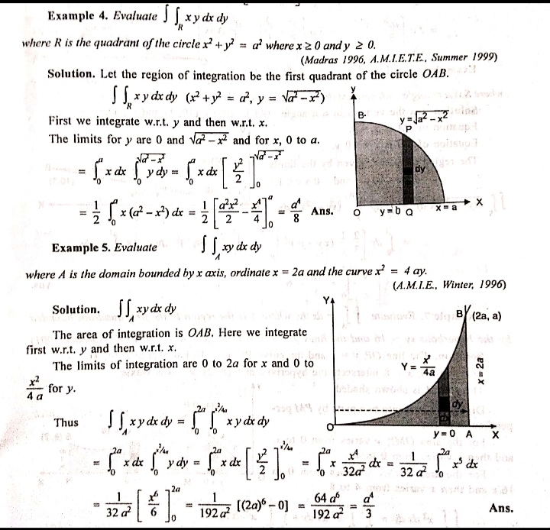

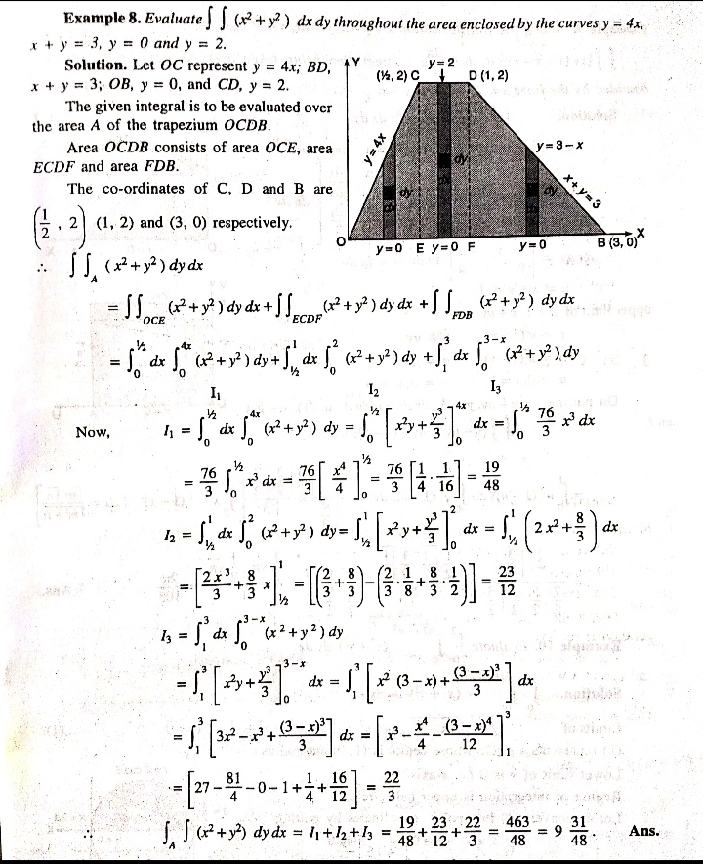  
**Triple Integrals**

Evaluate: $\int_{0}^{1}{\int_{0}^{\sqrt{1-x^{2}}}{\int_{0}^{\sqrt{1-x^{2}-y^{2}}}{xyz dz dy dx}}}$

**Soln. $\int_{0}^{1}{\int_{0}^{\sqrt{1-x^{2}}}{\int_{0}^{\sqrt{1-x^{2}-y^{2}}}{xyz dz dy dx}}}$**

$$=\int_{0}^{1}{\int_{0}^{\sqrt{1-x^{2}}}{xy{\left[\frac{z^{2}}{2}\right]}_{0}^{\sqrt{1-x^{2}-y^{2}}}}}dydx=\frac{1}{2}\int_{0}^{1}{\int_{0}^{\sqrt{1-x^{2}}}{xy(1-x^{2}-y^{2})}}dydx$$

$$=\frac{1}{2}\int_{0}^{1}{\int_{0}^{\sqrt{1-x^{2}}}{(xy-x^{3}y-{xy}^{3})}}dydx$$

$$=\frac{1}{2}\int_{0}^{1}{{\left[\frac{xy^{2}}{2}-\frac{x^{3}y^{2}}{2}-\frac{{xy}^{4}}{4}\right]}_{0}^{\sqrt{1-x^{2}}}}dx$$

$$=\frac{1}{8}\int_{0}^{1}{[2x(1-x^{2})-2x^{3}(1-x^{2})-x{\left(1-x^{2}\right)}^{2}]}dx$$

$$=\frac{1}{8}\int_{0}^{1}{[2x-2x^{3}-2x^{3}+2x^{5}-x+2x^{3}-x^{5}]}dx$$

$$=\frac{1}{8}\int_{0}^{1}{[x-2x^{3}+x^{5}]}dx$$

$$=\frac{1}{8} {\left[\frac{x^{2}}{2}-\frac{2x^{4}}{4} +\frac{x^{6}}{6}\right]}_{0}^{1}=\frac{1}{8}\left(\frac{1}{2}-\frac{1}{2} +\frac{1}{6}\right)= \frac{1}{48}$$

Evaluate:

$\iiint_{R}{(x-2y+z)dxdydz}, R: 0≤x≤1, 0≤y≤x^{2} , 0≤z≤x+y$

Soln. $\iiint_{R}{(x-2y+z)dxdydz}$

$$=\int_{0}^{1}{\int_{0}^{x^{2}}{\int_{0}^{x+y}{(x-2y+z)dzdydx}}}$$

$=\int_{0}^{1}{\int_{0}^{x^{2}}{{\left[xz-2yz+z^{2}\right]}_{0}^{x+y}}}$ dydx

$=\int_{0}^{1}{\int_{0}^{x^{2}}{\left(x^{2}+xy-2xy-2y^{2}+\frac{{\left(x+y\right)}^{2}}{2}\right)dydx}}$

$$=\frac{3}{2}\int_{0}^{1}{\int_{0}^{x^{2}}{\left(x^{2}-y^{2}\right)dydx}}$$

$$=\frac{3}{2}\int_{0}^{1}{{\left[x^{2}y-\frac{y^{3}}{3}\right]}_{0}^{x^{2}}}$$

$=\frac{3}{2}\int_{0}^{1}{(x^{4}-\frac{x^{6}}{3})}$ dx ${=\frac{3}{2}\left[\frac{x^{5}}{5}-\frac{y^{7}}{21}\right]}_{0}^{1}=\frac{8}{35}$

**Change of variable**

Sometime double , triple integral easily be evaluated by changing the dependent variables by suitable transformations .

Let $x=f_{1}\left(u,v\right)$, $y=f_{2}\left(u,v\right)$, the double integral

$$\iint_{R}{f\left(x,y\right)dxdy=}\iint_{R^{/}}{f\left(f_{1}(u,v),f_{2}(u,v)\right) \left|J\right|dudv}$$

where *J*= Jacobian = $\frac{∂(x,y)}{∂(u,v)}=\left|\begin{matrix}\frac{∂x}{∂u} & \frac{∂x}{∂v} \\ \frac{∂y}{∂u} & \frac{∂y}{∂v}\end{matrix}\right|$

similarly for triple integral can be written as

$$\iiint_{R}{f\left(x,y,z\right)dxdydz=}\iiint_{R^{/}}{f\left(f_{1}\left(u,v,w\right), f_{2}\left(u,v,w\right),f_{3}\left(u,v,w\right)\right)\left|J\right|dudvdw}$$

and $J=\left|\begin{matrix}\frac{∂x}{∂u} & \frac{∂x}{∂v} & \frac{∂x}{∂w} \\ \frac{∂y}{∂u} & \frac{∂y}{∂v} & \frac{∂y}{∂w} \\ \frac{∂z}{∂u} & \frac{∂z}{∂v} & \frac{∂z}{∂w}\end{matrix}\right|$